SPH4U0 Key Math Skills Review *LASS Physics Name:_______*

**Contents:**

|  |  |
| --- | --- |
| 1. Rational Expressions, Polynomial Expressions and Factoring 2. Linear Functions |  |
| 1. Solving Systems of Equations |  |
| 1. Angle Theorems |  |
| 1. Basic Trigonometry |  |
| 1. Sine and Cosine Laws |  |

**Practice: Rational Expressions, Polynomial Expressions and Factoring:**

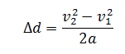 1a)  1b)  1c)

Simplify the units on the right side of the equation to demonstrate that distance units result. *d- metres (m), v-speed (m/s), a-acceleration m/s2*

**2. Expand and Simplify: 3. Common factor the following expression:**

 



**Answers:** *1a. -11/65 1b. 8/11* 2.  3.

**Practice: Linear Functions**

**4.Graph the linear relation given by: **

1. What are the slope, the x-intercept and the y-intercept?

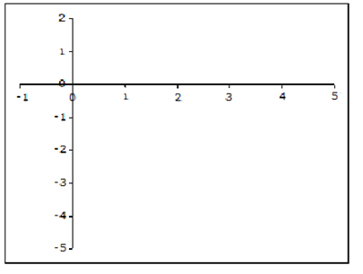

Analysis:

*Answers: a) -3/5, 5/3, 1*

**Practice: Solving Systems of Equations**

5. Find the solution (intersection point) of the following lines:



**Answers**: 4 ) *-3/5, 5/3, 1 5) (1/4, -1/4)*

Angle Theorems

|  |  |  |
| --- | --- | --- |
| **Theorem Name** | Description | Diagram |
| **Opposite Angle theorem** | 2 intersecting lines produce 2 sets of equal opposite angles: |  |
| **Supplementary Angle Theorem** | A straight line represents 180°: |  |
| **Interior Angles in a Triangle Theorem** | The sum of the interior angles of a triangle sum to 180°: |  |
| **Parallel line theorem** | A line intersecting two parallel lines makes a pattern of equivalent angles as shown in the diagram.  “Z “ pattern – alternate angles equal  “C” pattern- co-interior angles add to 180°  “F” pattern-corresponding angles equal | θ + α = 180 ° |

**Practice: Angle Theorems**



6a. Find : 6b. Find :



6c. Find : 6d. Find :

***Answers:*** *6a. From the opposite angle theorem  must be 23°*

*6b. From the opposite angle theorem  must be 23° (180° –  = 157°).*

*6c.  must be 33° (180° – 123° = 57°, 90° - 57° = 33°, or 180° - 90° - 57° = 33°).*

*6d.  must be 97°*

**Practice: Basic Trigonometry**

In a right triangle (one with one 90° angle) the ratios of the sides of the triangle are defined with specific names: sine (sin) cosine (cos) and tangent (tan). These ratios are all related to one another by the angle made by the respective sides and by the Pythagorean theorem, x2 + y2 = r2.



***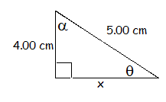*Question 7: Find the values of   and x for the diagram below**:

**Solution:**

**Practice:** **Sine and Cosine Laws**

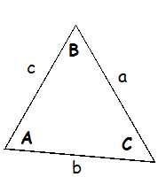There are two laws that help you figure out unknown side lengths and angles in a non-right triangle, the sine law and the cosine law.

**Sine law:** 

*Note angles are denoted by capital letters.*

*A given angle is denoted by the same letter as the opposite side!*

**Cosine law:**  

**Question 8: Find all unknown sides and angles in the triangle below. Diagram is NOT to scale!**

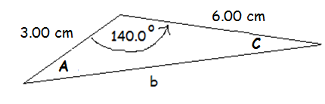 -

**Answers:** 7. *x=3.00 cm θ = 53.1°, α = 36.9° 8. b= 8.52 cm, A= 26.9°, C = 13.1°*